Operating system sec-2
2520030199-K.VISHNU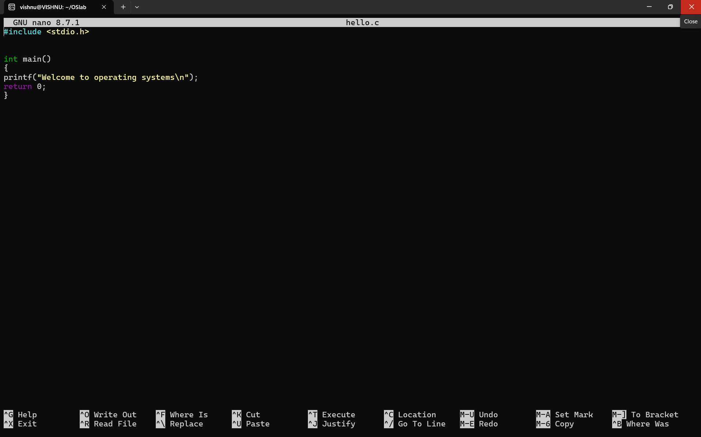
First programOUTPUT: 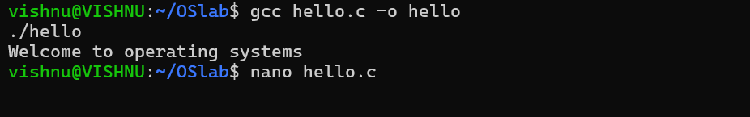

Second code:
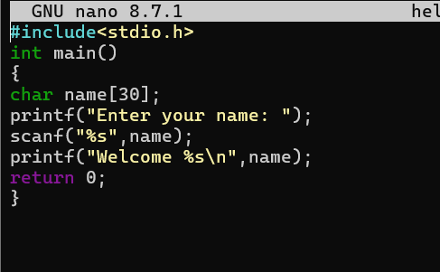
OUTPUT:
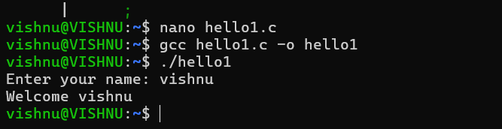
Third code: 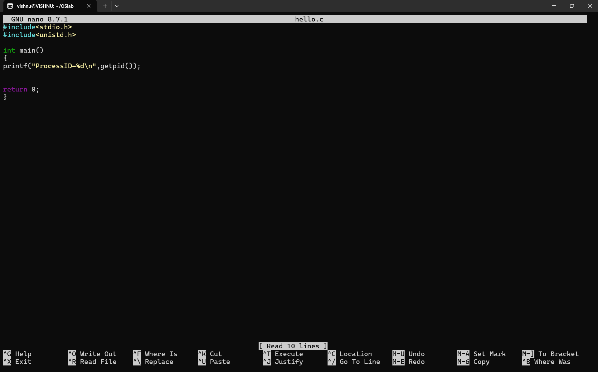
OUTPUT: 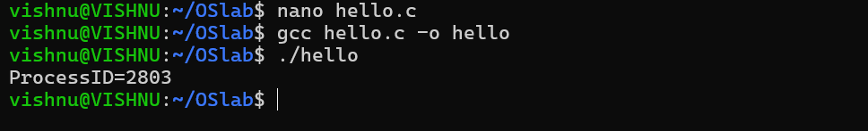
Fourth program:

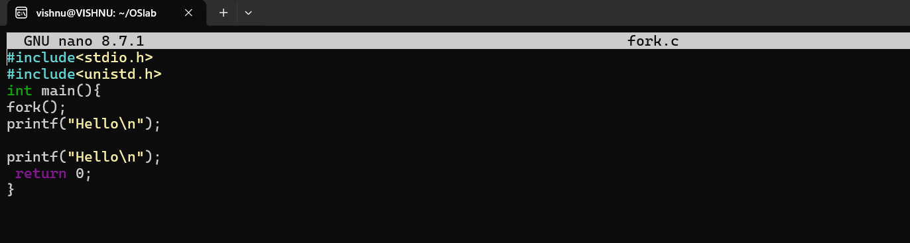output:
